Technical Data Sheet

Product Name：PLCC-5050 Green SMD Chip LED

Part Number： HT61-2301UBGUBGUBGC(S)

Customer：

Customer PN：

Version No.： A.2

Date： 2009.01.01

Customer Approval

Instituted By： Checked By: Approved By：

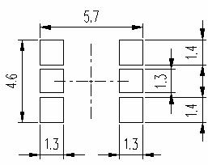
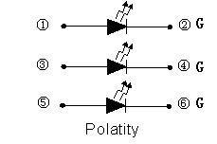

1、Features

● Package ( L/W/H ) : 5.4 × 5.0 × 1.6 mm
● Color : Ultra Bright Green
● Lens: Water Clear Flat Mold
● EIA STD Package
● Meet ROHS, Green Product
● Compatible With SMT Automatic Equipment
● Compatible With Infrared Reflow Solder And Wave Solder Process

2、 Package Profile & Soldering PAD Suggested

①

③

⑤

MARK

Φ3.3

②

④

⑥

Notes: 1. All dimensions are in millimeters ;
2. Tolerance is ± 0.10 mm unless otherwise noted.

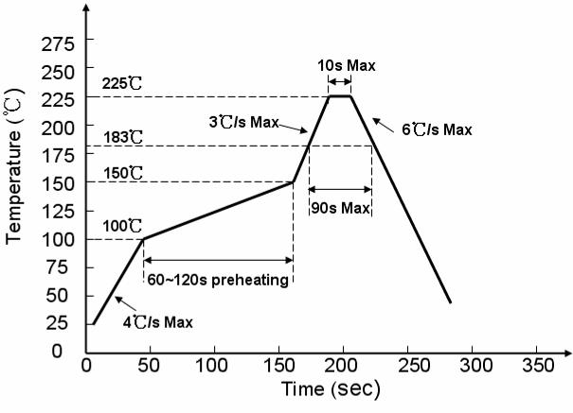
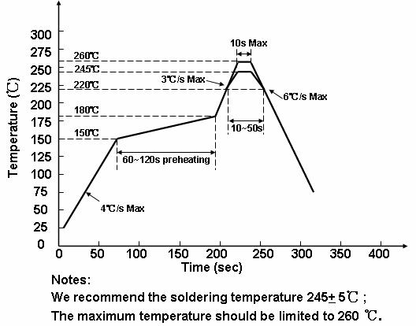

3、 Soldering Profile Suggested

3.1、For Lead Solder

3.2、For Lead Free Solder

2 of 10

Technical Data Sheet
Part No. : HT61-2301UBGUBGUBGC(S)
Version A.2 Issued date 2009.01.01 Page

4． Absolute Maximum Ratings At Ta=25℃

3 of 10

Parameter

Power Dissipation

Symbol

Pd

G1
G2
G3

Rating

90
90
90

Unit

mW

Peak Forward Current
(1/10 Duty Cycle, 0.1ms Pulse Width)

DC Forward Current

Reverse Voltage

Operating Temperature Range

Storage Temperature Range

I_{FP}

IF

VR

Topr

Tstg
G1
G2
G3
G1
G2
G3
G1
G2
G3
100
100
100
30
30
30
5
5
5

-30°C ~ + 85°C

-40°C ~ + 90°C

mA

mA

V

Soldering Condition

Tsol

Reflow soldering : 260°C For 5 Seconds
Hand soldering: 300°C For 3 Seconds

Technical Data Sheet
Part No. : HT61-2301UBGUBGUBGC(S)
Version A.2 Issued date 2009.01.01 Page

5、 Electrical Optical Characteristics At Ta=25℃

4 of 10

Parameter

Symbol

Color

G1

Min.

---

Typ. Max.

1000 ---

Unit

Test Condition

Luminous Intensity

Dominant Wavelength

Peak Wavelength

Spectral Line Half-Width

Forward Voltage

Reverse Current

Viewing Angle
IV

λd

λp

Δλ

VF

IR

2θ1/2
G2
G3
G1
G2
G3
G1
G2
G3
G1
G2
G3
G1
G2
G3
G1
G2
G3
---
---
---
---
---
---
---
---
---
---
---
---
2.8
2.8
2.8
---
---
---
---
1000
1000
525
525
525
530
530
530
35
35
35
---
---
---
---
---
---
120
---
---
---
---
---
---
---
---
---
---
---
3.6
3.6
3.6
10
10
10
---
mcd

nm

nm

nm

V

uA

deg
IF = 20mA

IF=20mA

IF=20mA

IF=20mA

IF=20mA

VR=5V

IF = 20mA

Notes: 1. Luminous intensity is measured with a light sensor and filter combination that approximates the
CIE eye-response curve.
2. θ1/2 is the off-axis angle at which the luminous intensity is half the axial luminous intensity.
3. The dominant wavelength, λd is derived from the CIE chromaticity diagram and represents the
single wavelength which defines the color of the device.

